Wholesale Operation Manual
Business overview
When you need to purchase products in bulk, you can choose the "Wholesale" mode. The platform will arrange delivery to your designated warehouse, and the delivery fee will be charged in the order process. (Currently supports FBA warehouse, WFS warehouse)

Operation process
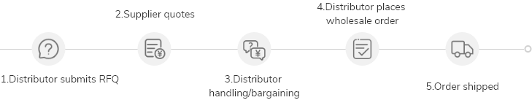
Operation steps
- Select the products you want to wholesale
- On the product list page, you can search for products that support wholesale business.
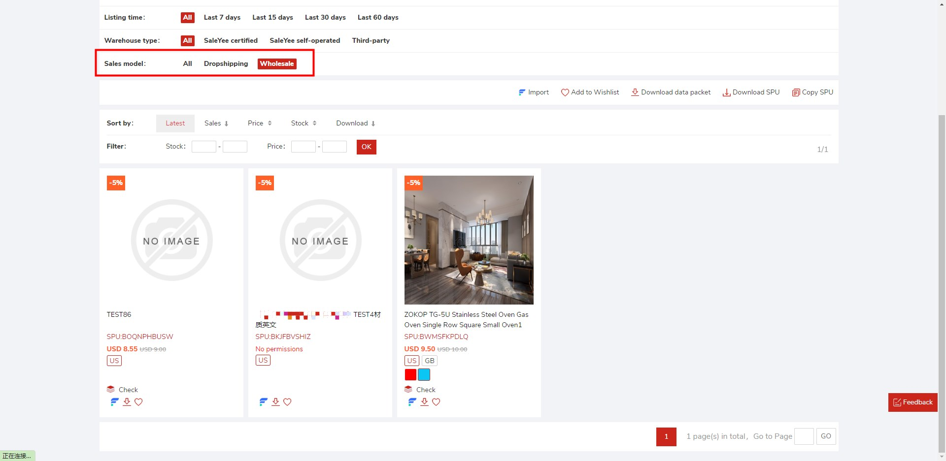
- On the product details page, if the product supports wholesale, there will be a "Wholesale" tab.
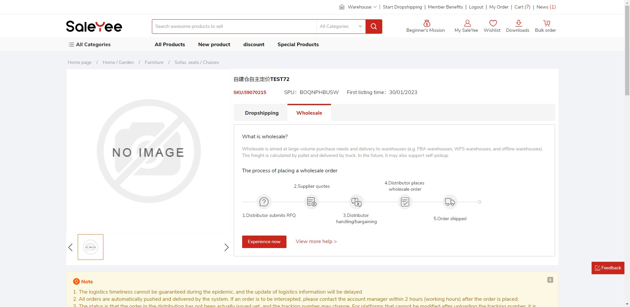
- Distributor submits RFQ
- You can click the [Inquiry Now] button on the product details page, or add the product to the wholesale cart, and select products in batches in the cart to inquire together.
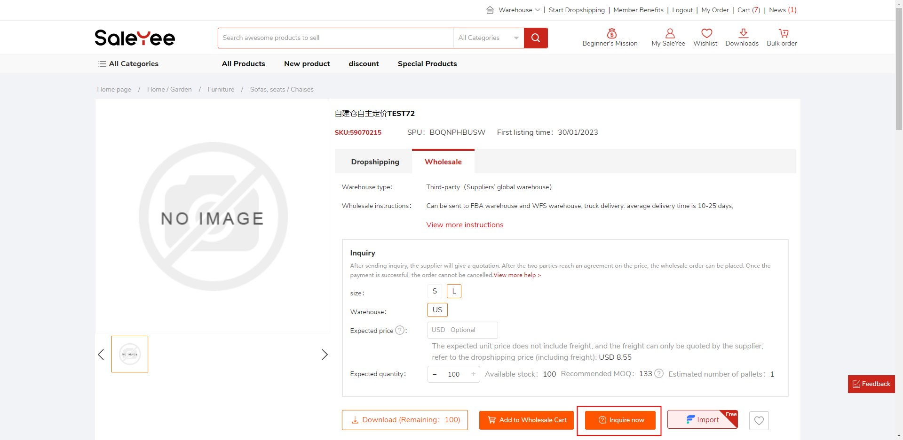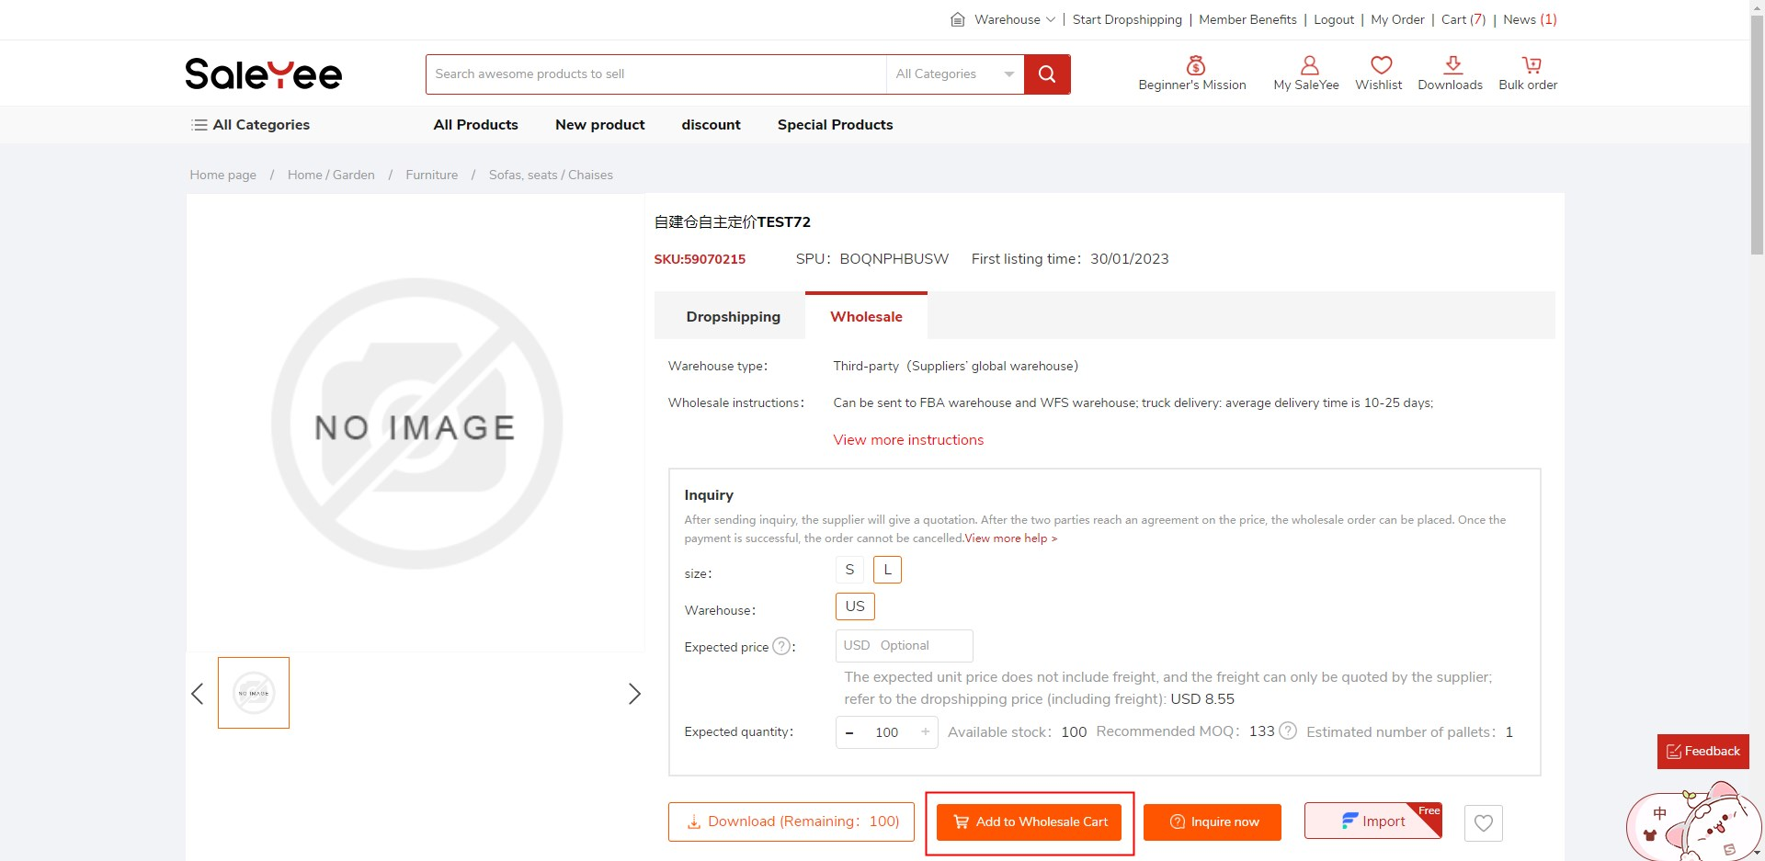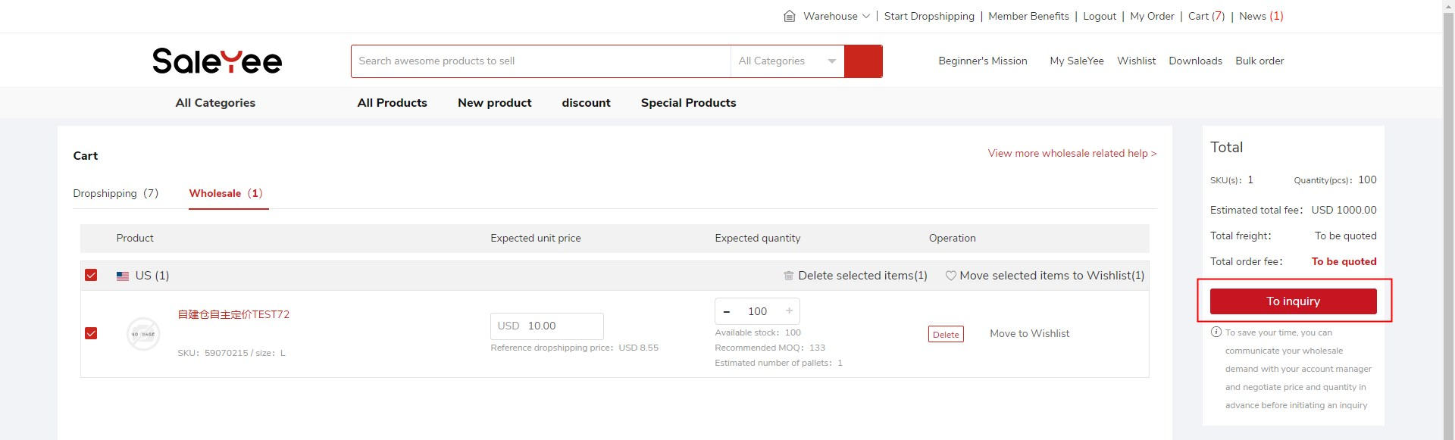

- Fill in the information required for the RFQ, including address information and warehouse information.
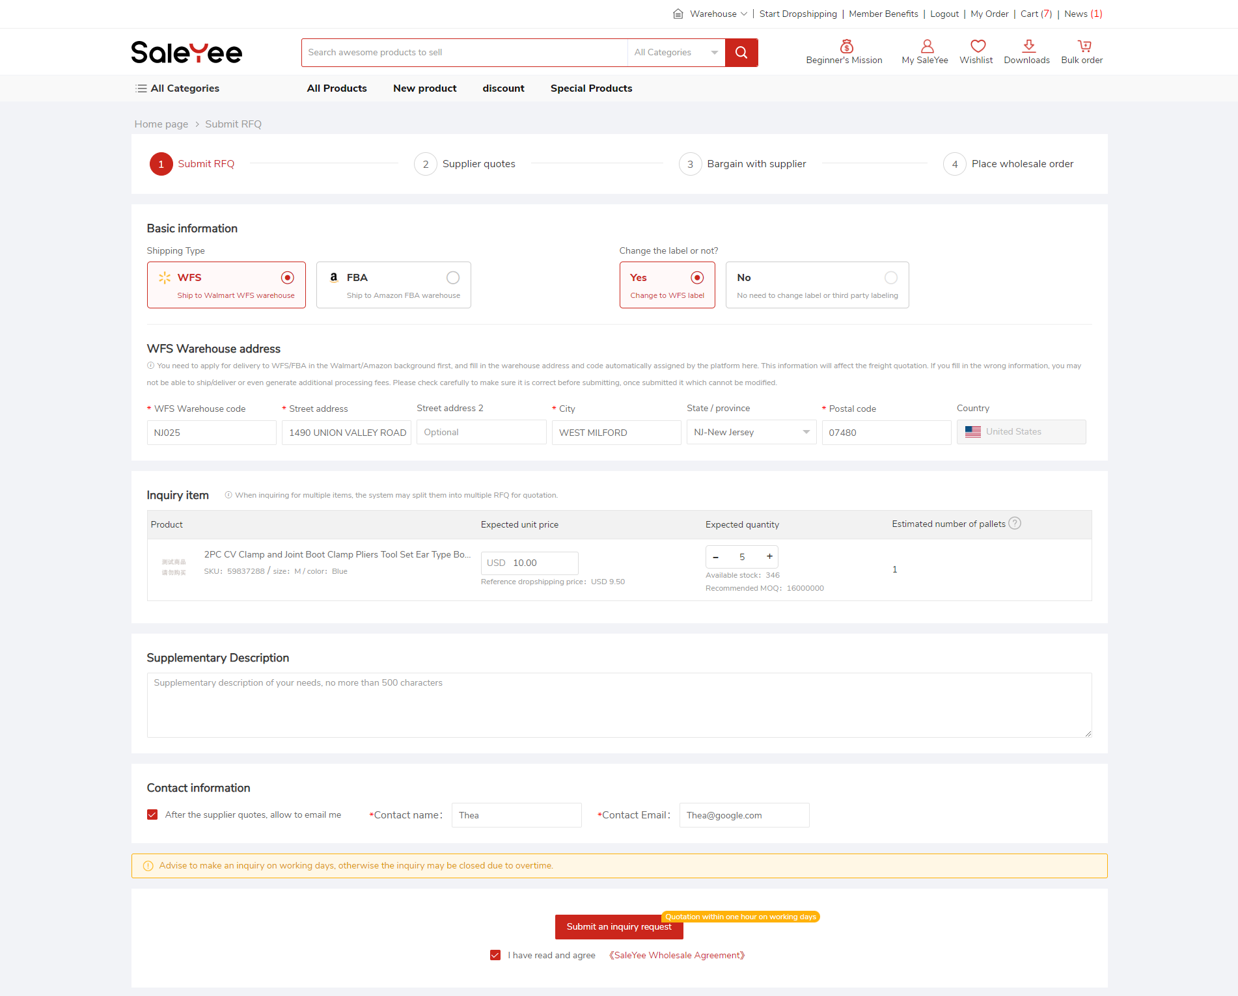
- After submitting an RFQ, you can view the status in the RFQ list.
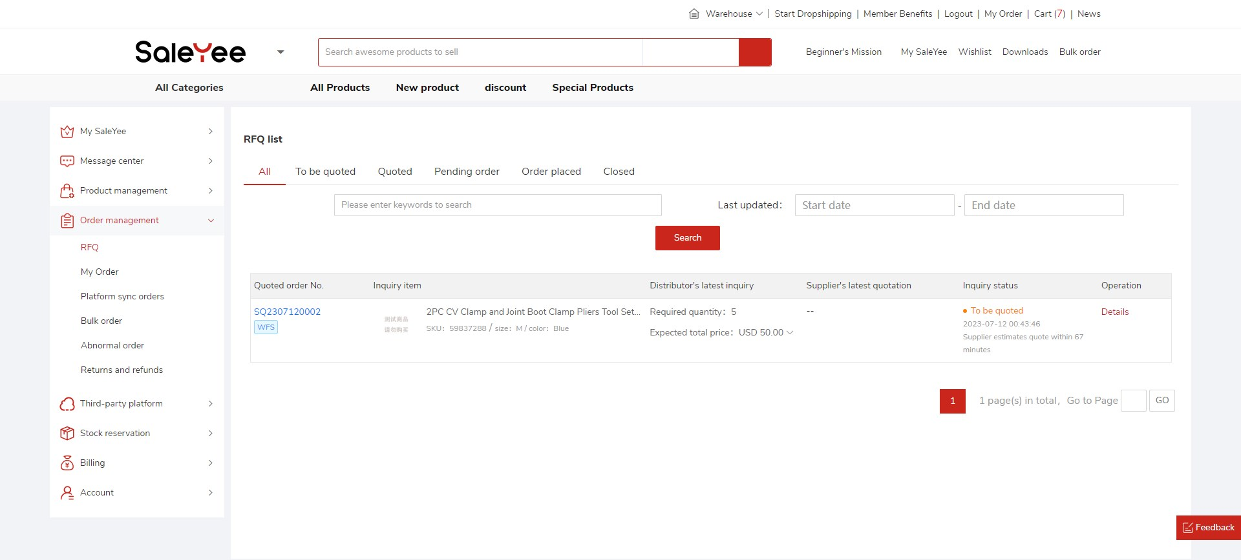
- Supplier quotes
- The supplier is expected to quote within 1 hour. After the supplier quotes, you also need to process the quotation within 1 hour. If not processed within 1 hour, the system will automatically close the RFQ.
- The supplier may offer a quotation for the first time to process your inquiry, or reject your inquiry due to some reasons, and the RFQ will be automatically closed at this time.
- Distributor processes quotation from supplier
To process the quotation on the RFQ details page, you can: agree the quotation/cancel the inquiry/bargain:
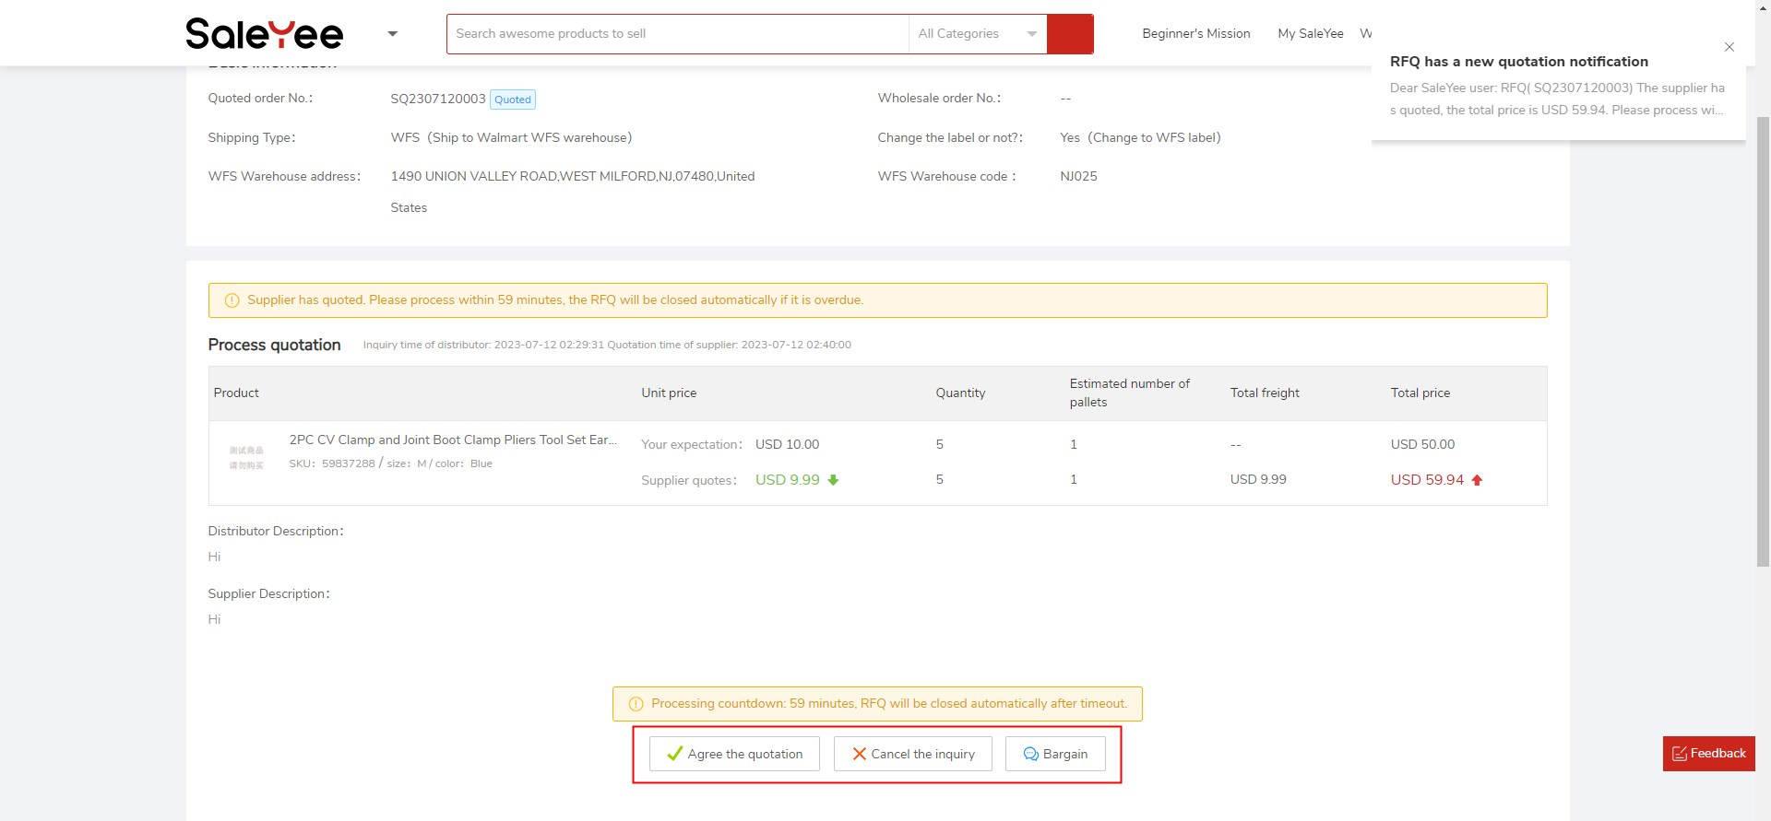
- Agree the quotation: Agree with the quotation from supplier which will be used as the final price of the wholesale order.
- Cancel the inquiry: Do not agree with the quotation from supplier and close this RFQ.
- Bargain: If you are not satisfied with the quotation, you can bargain with the supplier by filling in your expected unit price and quantity, and waiting for the reply from supplier. Each RFQ can be bargained 2 times.

- Bargaining with suppliers
Click the [Bargain] button and re-enter your expected unit price, quantity and remarks to submit.
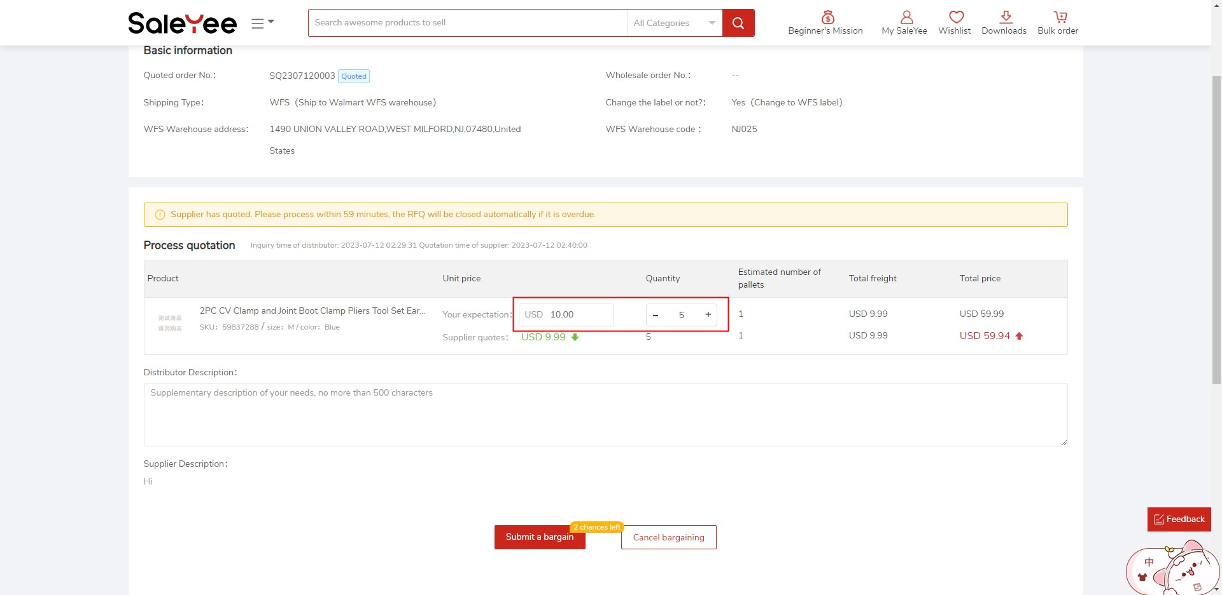
After submission, the supplier will process it within 1 hour, and the processing results may include: Agree/Reject/Adjust the quotation:
- Agree: The supplier agrees to your quotation, and you can directly place a wholesale order after supplementing the warehouse information.
- Rejection: The supplier rejects your proposal and still maintains the last quotation, and you can only accept or cancel the inquiry.
- Adjust the quotation: the supplier has revised the quotation again based on your proposal, and you need to process it again.

- Distributors supplement warehouse information
After consensus with the supplier, the status of the RFQ will be changed to ‘Pending Order’. At this time, you need to supplement the warehouse information within 1 hour.
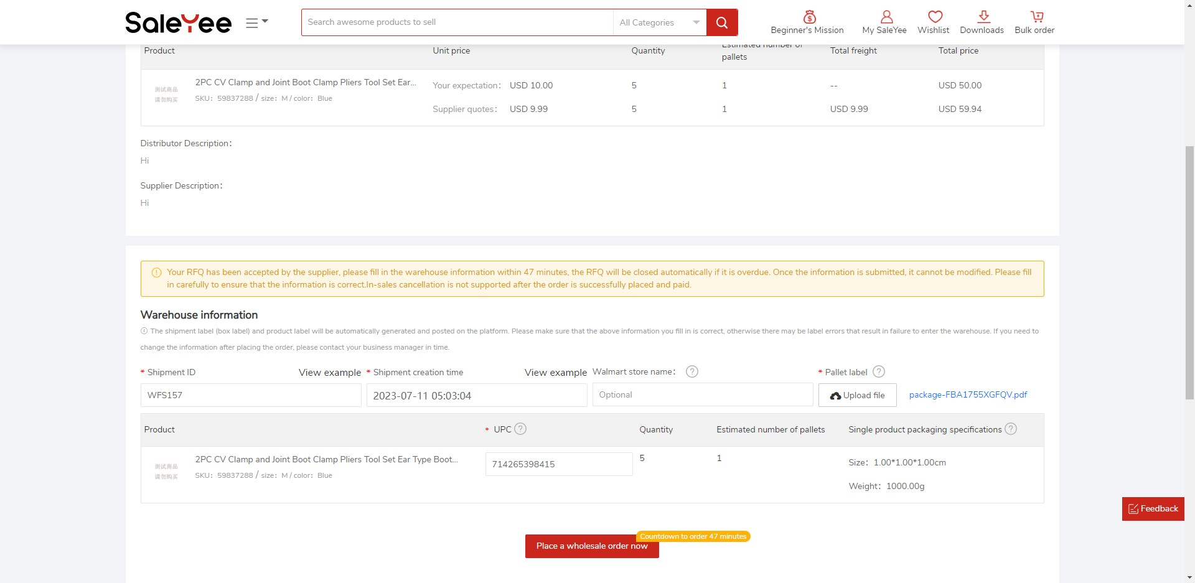
- Distributor places wholesale order
After filling in the warehouse information, you can place a wholesale order and make payment.
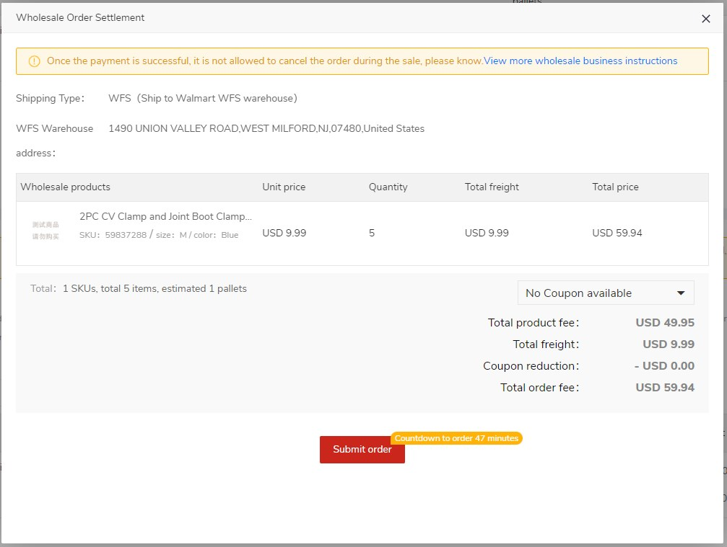
Wholesale orders that have been paid will be displayed under the [My Orders] - [Wholesale] tab.
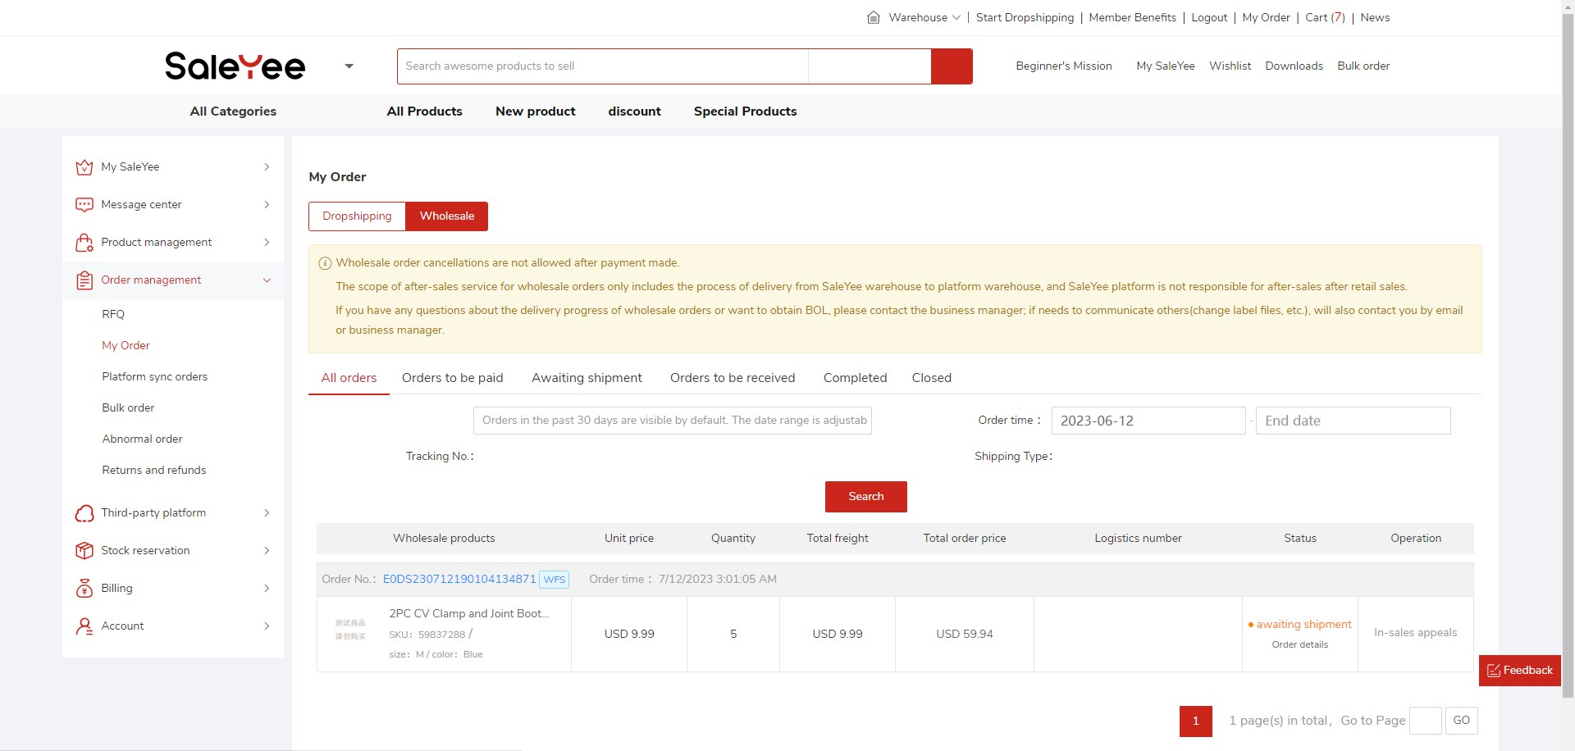
- Order Shipment
After the order is shipped, the tracking number will be sent to SaleYee platform, please check it in the wholesale order list.
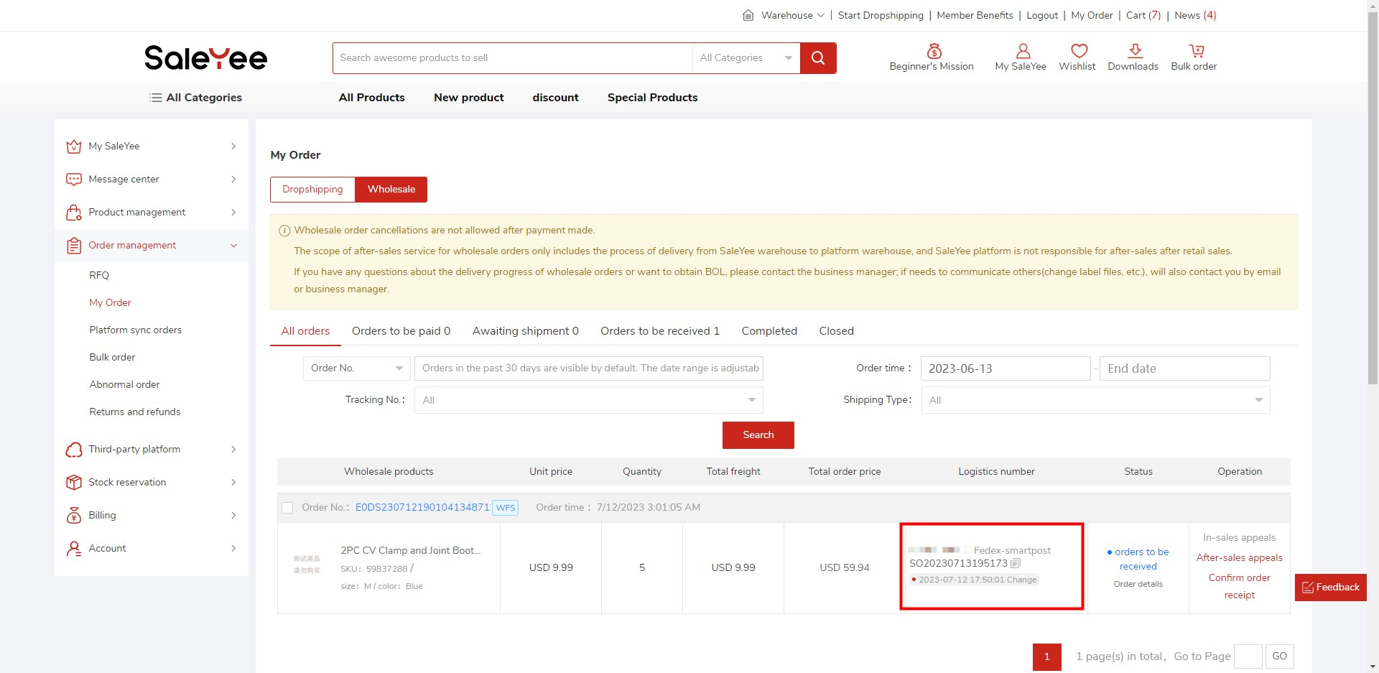
Precautions
- Wholesale orders do not support in-sale cancellation.
- The scope of after-sales service for wholesale orders only covers the process of delivery to your destination warehouse, and SaleYee Platform is not responsible for after-sales arising from subsequent sales.
- Wholesale orders are only supported after sale for refund only, returns are not supported.
- The time limit for processing the RFQ is 1 hour, overtime processing of RFQ will be automatically closed. Please pay more attention to the internal letters and SMS (email) notifications from the platform.

Q&A
Q1: Is there any MOQ requirement for wholesale?
A1: No. But the system will prompt a suggested MOQ. The freight for wholesale products is charged by pallet. The recommended is the MOQ that can hold in one pallet. You can also place an order below the MOQ, but the freight will be calculated by one pallet.
Q2: Can wholesale products enjoy membership discounts and promotional offers?
A2: The wholesale order is a quotation mode, and the final transaction price is the price agreed upon by the distributor and the supplier in the RFQ. Member discounts and promotional offers are no longer involved, but purchase coupons can still be used.
Q3: Do all products on the platform support wholesale?
A3: At present, most products in the US region support wholesale business.
Q4: Can the reservation stock be used for wholesale?
A4: Not supported yet.
Q5: Can wholesale orders be sent to remote warehouses?
A5: The details are subject to the quotation from supplier. If it cannot be sent, the supplier will reject the inquiry and give the reason.
If you have other questions, you can consult your account manager.

